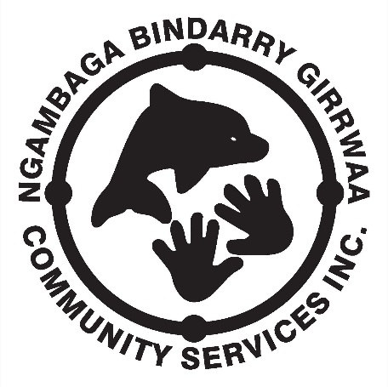
NEWSLETTER
MARCH/APRIL 2016 – Issue 10

I pay respect to the past, present and future Elders of the Nambucca Valley region on whose land I walk, work and live.
Activities and operations of Ngambaga Bindarry Girrwaa Community Service are in full swing with Recipient; Women’s; and Men’s days all being well received and attended. NBGCS held the second Clients meeting for 2016 on February 19th, attendance was very good and a lot of great discussion took place. Some of the points that came out of the discussion where:
- Clients must attend 12 NBGCS events (outings; meetings; activity days; etc) to be eligible to attend the Olympics;
- Clients who only wish to be spectators are still able to attend;
- Clients who are known to have a physical disability that may hinder their ability to participate in the Olympics will be requested by NBGCS Management to produce a statement from their Doctor that clears them for competition, the certificate should state something like ‘Gary Butler is capable of performing medium to heavy physical activity for an extended period of time.’ NBGCS can refuse to allow the Client to participate if they do not have the requested clearance certificate.
- There is a limit of 35 Clients/staff attending as this is the limit of our transport capabilities;
- Clients must register for the Elder’s Olympics by 29th February 2016;
- Client fees ($75) must be paid by 4th April 2016;
- Clients will travel to Port Stephens on Tuesday 5th April, compete in the Olympics on Wednesday 6th April, and return to the Nambucca Valley on Thursday 7th April;
- Accommodation will be at the Peninsula Hotel Nelson Bay/Port Stephens and will be on a shared basis.

I would like thank all the NBGCS Clients who attended the meeting for their input and participation.
NBGCS have started to increase staff levels to assist in the provision of quality services to our clients. Over the coming weeks you will meet and I hope welcome the following staff to the organisation:
- Commonwealth Home Support Program Coordinator – Rebecca Steele. Rebecca’s role will be to coordinate the social activities and provision of domestic services to clients.
- Social Support Worker – Allira Jerrett. Allira will provide assistance to clients on activity days and support both Program Coordinators with administration activities.
- Social Support Worker – Lorraine Donovan. Lorraine will provide assistance to clients on activity days.
- Domestic Worker – Donna Brown. Donna will be providing in-house domestic services to our referred clients.
- Domestic Worker – Gary Jarratt. Gary will be providing outside-house domestic services to our referred clients.
These staff will assist our current staff, Rachael Gillin; Rachael Roberts; Zac Stadhams; Bill Kennedy; Robert Edwards; and Katrina Davis to lift the quantity and quality of service NBGCS can offer to Aged and Disabled clients.
NBGCS has expanded services to include in-house and outside-house domestics for clients referred to the organisation from ACAT and RAS assessments to deliver components of Aged Care packages. NBGCS is only supplying limited services to package holders at this time due to insufficient qualified staff to deliver all package options. At this point in time NBGCS can and does deliver:
- Social activities – group; and individual;
- Domestics – in-house and outside-house;
- Individual support – transport to Doctors appointments, shopping, etc.
- Respite – group; individual; and flexible.

I look forward to the exciting year ahead.

Enjoy life and have a great day.

Gary Butler

Disability Program Update
by Rachael Gillin
Giinagay, Jinda’s and Gagu’s.
Thanks to everyone who have participated in planning this past month. Together we can begin to work towards helping each other achieve their goals.
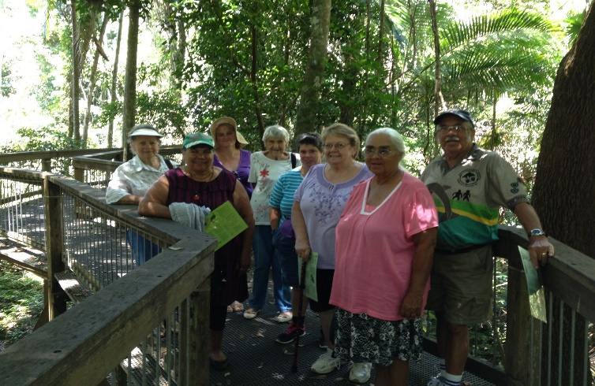
Like many other services NBGCS, is keen to see the rollout of the NDIS. We encourage you to become informed and start researching and looking at what you want to include to allow you to have a ‘good life’.
Both myself and NBGCS chairperson Bill Kennedy will be attending the ACT NOW III Disability Conference to gather up to date information that will assist you with future changes.
We WILL keep you informed.

Early Links Program
by Rachael Gillin
Early Links – Strengthening Supports for Children and their Families from Red Rock to Kempsey.
How we can help:
- Information, referrals and access to community
- Advocacy on your behalf to get the services you need
- Diagnosis information support
- Assistance to gain a diagnosis
Enquires can be made by phone, SMS, email or in person at our office.

Respite Program

MARCH 2016 Events

CARER / RECEIVER DAY | RESPITE DAY | RESPITE DAY | RESPITE DAY | RESPITE DAY
Tuesday 1 | Tuesday 8 | Tuesday 15 | Tuesday 22 | Tuesday 29
Rainforest  Historical walk  Dorrigo National Park  Bellingen  Picnic Lunch  Cost $5.00  Includes meals | River walk  Luncheon  Macksville  RSL Macksville  Cost $5.00  Includes meals | Beach walks / pamper  Stuarts Point / Scotts Head  Picnic Lunch  Cost $8.00  Includes meals and materials | Nature walk / craft  Bongil Bongil National Park  BBQ lunch  Cost $8.00  Includes meals and craft materials | DIY Garden  NBGCS Office  BBQ Lunch  Cost $5.00  Includes meals
Bus leaves office at 8:30am.  Easy walk, accessible track -please wear appropriate shoes and hat | Bus leaves office at 8:30am.  Ladies as this is your day please dress to impress. | Bus leaves office at 8:30am.  Bring your own towel and hat | Bus leaves office at 8:30am.  Remember to bring your hat | Bus leaves office at 8:30am.
Please help keep our fees down by contributing to costs. Thank you

Women’s Program

WOMEN’S DAY | WOMEN’S DAY | WOMEN’S DAY | WOMEN’S DAY | WOMEN’S DAY
Wednesday 2 | Wednesday 9 | Wednesday 18 | Wednesday 23 | Wednesday 30
Office | Port Macquarie  Koala Hospital  Glass House Gallery  Cost $5.00  Includes meals | Office | Woodcraft gallery  Bellingen  Cost $5.00  Includes meals | Office
Bus leaves office at 8:30am. | Bus leaves office at 8:30am.  Remember to bring your hat | Bus leaves office at 8:30am. | Bus leaves office at 8:30am.  Remember to bring your hat | Bus leaves office at 8:30am.

Men’s Program

MEN’S DAY | MEN’S DAY | MEN’S DAY | MEN’S DAY | MEN’S DAY
Thursday 3 | Thursday 10 | Thursday 17 | Thursday 24 | Thursday 31
Hat Head  Lunch  Cost $5.00  Includes meals | Putt Putt Golf at Big Banana, Coffs Harbour  Lunch  Cost $5.00  Includes meals | Fishing At Welsh’s Pioneer Park  Lunch  Cost $5.00  Includes meals | 9 Pin Bowling at Coffs Harbour  Lunch  Cost $5.00  Includes meals | Stuarts point  Lunch  Cost $5.00  Includes meals
Bus leaves office at 8:30am.  Remember to bring your hat | Bus leaves office at 8:30am.  Remember to bring your hat | Bus leaves office at 8:30am.  Remember to bring your hat and fishing gear | Bus leaves office at 8:30am.  Remember to bring your hat | Bus leaves office at 8:30am.  Remember to bring your hat

8 March – International Women’s Day

Did you know that March 8 is International Women’s Day and people worldwide celebrate this wonderful day that honour’s ALL women.
“Taking joy in living is a woman’s best cosmetic.”– Rosalind Russell

MARCH CALENDAR 2016
MON | TUE | WED | THU | FRI
 | 1. | 2. | 3. | 4.
7. | 8. | 9. | 10. | 11.
14. | 15. | 16. | 17. | 18.
21. | 22. | 23. | 24. | 25.
28. | 29. | 30. | 31.
HAPPY BIRTHDAY!
Roseina Boston Martin Ballangarry Val Cohen
Rosalind Donovan Wade Blair Elaine Callaway
Anthony Gillin

APRIL CALENDAR 2016
MON | TUE | WED | THU | FRI
 |  |  |  | 1.
4. | 5. | 6. | 7. | 8.
11. | 12. | 13. | 14. | 15.
18. | 19. | 20. | 21. | 22.
25. | 26. | 27. | 28. | 29.
HAPPY BIRTHDAY!
Robert Edwards Barry Phyball Rhonda Donovan
Marilyn Smith

NGAMBAGA BINDARRY GIRRWAA COMMUNITY SERVICE INC.
CLIENT CODE OF CONDUCT
Client ‘Code of Conduct’ must be practiced when involved in NBGCS activities.
All clients are required to:
- show your companions courtesy and respect;
- take any concerns you may have to the field worker;
- listen to the field workers instructions;
- Not engage in disruptive or argumentative behaviour.
If a client cannot be respectful to others and continually disturbs other people then they may be asked to leave the outing and in extreme cases not be offered future services. Therefore, if a participant feels they cannot be respectful they should decide for themselves to not attend that activity. NGAMBAGA BINDARRY GIRRWAA COMMUNITY SERVICE INC.

