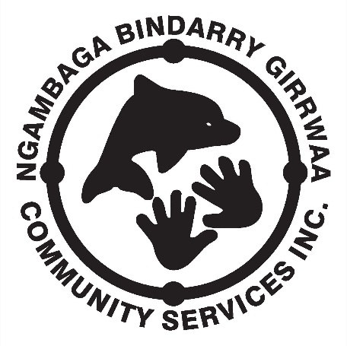
NEWSLETTER
MARCH/APRIL 2016 – Issue 10

Disability Program Update
by Rachael Gillin

Early Links Program
by Rachael Gillin

Our Early Links Program provides a range of supports for young children with developmental delay, disabilities and / or special needs.
Our Linker will assist with:
- General development concerns
- Information and support for families to find out about their child’s disability needs
- Identifying concerns / goals and developing plans
- Connecting with other parents, community and service providers

“Yes, he is in day care now and loves it.
Doesn’t get frightened when I leave”
KB
- Intensive Family support.

Respite Program

FEBRUARY 2016 Events

CARER / RECEIVER DAY | RESPITE DAY | RESPITE DAY | RESPITE DAY
Tuesday 1st | Tuesday 8th | Tuesday 15th | Tuesday 22nd
Please help keep our fees down by contributing to costs. Thank you

Carers ONLY day - Special Event

Carers have been fortunate to receive additional funding from Carers NSW Together Program – where they will be rewarded for their roles with a mystery tour. Details are being finalised with information provided directly to carers once confirmed.
Please note that places are limited to 10, you are asked to get in early with your names.

GIRRWAA WELLNESS DAY – spread the word

There is no secret our Wellness Days are back again this year with more tips from various health professionals on staying healthy.
This is a community event, so please tell your friends and your families. Enjoy getting healthy together.
Transport will be available for those whom need it, please contact the friendly staff to put your name down.
Girrwaa Wellness Day will recommence in March this year.

_________________________________________________________________________

Social Support Program

MARCH 2016 Events

WOMENS DAY | MENS DAY
Wednesday 2nd | Thursday 3rd
Wednesday 9th | Thursday 10th
Wednesday 16th | Thursday 17th
Wednesday 23rd | Thursday 24th

MARCH CALENDAR 2016
MON | TUE | WED | THU | FRI
 | 1. | 2. | 3. | 4.
7. | 8. | 9. | 10. | 11.
14. | 15. | 16. | 17. | 18.
21. | 22. | 23. | 24. | 25.
28. | 29. | 30. | 31.

APRIL CALENDAR 2016
MON | TUE | WED | THU | FRI
 |  |  |  | 1.
4. | 5. | 6. | 7. | 8.
11. | 12. | 13. | 14. | 15.
18. | 19. | 20. | 21. | 22.
25. | 26. | 27. | 28. | 29.

NGAMBAGA BINDARRY GIRRWAA COMMUNITY SERVICE INC.
CLIENT CODE OF CONDUCT
Client ‘Code of Conduct’ must be practiced when involved in NBGCS activities.
All clients are required to:
- show your companions courtesy and respect;
- take any concerns you may have to the field worker;
- listen to the field workers instructions;
- Not engage in disruptive or argumentative behaviour.
If a client cannot be respectful to others and continually disturbs other people then they may be asked to leave the outing and in extreme cases not be offered future services. Therefore, if a participant feels they cannot be respectful they should decide for themselves to not attend that activity. NGAMBAGA BINDARRY GIRRWAA COMMUNITY SERVICE INC.

