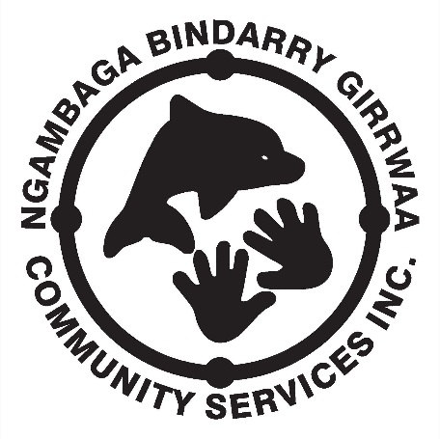
NEWSLETTER
May 2015 – Issue 9

I pay respect to the past, present and future Elders of the Nambucca Valley region on whose land I walk, work and live.
On the 27th March, NBGCS conducted the first Member’s meeting for 2015; attendance was very good with 23 Members participating. Presentations were given by the Departments of Aboriginal affairs and Prime Minister and Cabinet there were a number of issues raised and most Members had the opportunity to express their point of view regarding topics presented. DAA representatives assured those present that they would follow up on the concerns and give some feedback as soon as they have it. The Department of Health requested some assistance from Members to design some paintings for the new HealthOne building being constructed in Nambucca; canvases and paints should be at NBGCS office shortly.
The Elder’s Olympics are fast approaching as they are being held in Taree on 7th May 2015. The NBGCS staff are finalising accommodation; and transport this week. Some points to note for those Clients competing in the Olympics or attending as spectators:
- Recently all clients would have received a letter requesting medical information to be provided to NBGCS, could you please ensure that information has been given before the Olympics. The letter also requested clients to obtain a letter of fitness from their Doctor however this was meant only for Clients who are known to have a physical disability that may hinder their ability to participate in the Olympics. These Clients have been requested by NBGCS Management to produce a statement from their Doctor that clears them for competition, the certificate should state something like ‘(Client name here) is capable of performing moderate to heavy physical activity for an extended period of time.’ NBGCS can refuse to allow the Client to participate if they do not have the requested clearance certificate.
- There are 32 Clients and staff attending so NBGCS will supply all the transport;
- Clients are now registered for the Elder’s Olympics and no further registrations can be accepted;
- Client fees ($100) must be paid by Friday 1st May 2015;
- Any Client who has registered but not fully paid their fee by 1st May 2015 will not be able to attend however any monies they have paid will be refunded;
- Clients will travel to Taree on Wednesday 6th May, compete in the Olympics on Thursday 7th May, and return to the Nambucca Valley on Friday 8th May.;
- Accommodation will be at the All Seasons Motel Taree (the same as for Xmas lunch last year) and will be on a shared basis.

A message from our C.E.O

I would like thank all the NBGCS Members who attended the meeting for their input and participation.
The annual Client’s Easter lunch was held at Valla on Thursday 1st April; all who attended appeared to enjoy themselves and had a fun day.
There are a couple of activity housekeeping items that are being introduced to make things easier for Clients and help my staff run a smoother operation:
- When activities are held in the Bowraville activity room and food is being prepared for smoko and lunch my staff will prepare plates for those clients who require extra assistance before preparing the food for all other clients. I feel that this is necessary to allow my staff time to prepare and deliver the smoko and lunch without any client missing out.
- It has also became necessary to limit access to the kitchen area to NBGCS staff only (this includes Directors when conducting Corporation business).
It has also came to my attention that there is some misunderstanding regarding the purchase of lunch during outings and how much NBGCS will pay for lunch. Generally NBGCS has not placed a ‘cap’ on how much lunch can cost during an outing however it has been assumed that clients will not be overly extravagant and will order lunches within a reasonable cost bracket. However due to the recent incidences where lunch expenses were over the budgeted activity amount, I feel it is necessary for me to explain how NBGCS staff budget for lunches:
- Clients are contacted to see how many going on the outing and therefore how much money will be required to purchase lunches;
- The staff complete a request for the amount of money required, this request is then budgeted and approved by the CEO;
- Clients attend the venue and order lunch;
- NBGCS staff pays for the lunches using the NBGCS card.
This process usually works smoothly however during a couple of recent outings unregistered clients have attended. The increased number of clients has caused lunch to cost more than the amount approved to staff. In these circumstances it was necessary for the staff to place a limit on how much lunch would cost however if clients wanted to purchase a more expensive lunch then they were required to pay the extra costs themselves. To overcome this happening in the future only clients who have notified staff (registered to attend the activity) of their attendance will be covered for lunch by NBGCS. Clients who have not registered but wish to attend on the day will be required to cover their own costs for the activity; this includes lunch and any other costs involved in the activity. If a client is covering their own costs or wanting a more expensive lunch than what has been catered for than that client will need to make the payment themselves; staff will not make payment for the client from the NBGCS card.
I respectfully request that If you change your mind about attending an outing (either wanting to go or deciding not to go) please ring NBGCS and let staff know before the activity commences. This will avoid any disagreement in the future.
Enjoy life and have a great day.

Gary Butler

Hello All You Deadly Mob,
I would like to welcome our new trainee Zac Stadhams. Zac will be studying Cert III in Aged Care & Disability. And will work Tuesday, Thursday & Fridays.
Welcome back after our two week Easter break.
I trust that you all had a wonderful Easter, and enjoyed the Easter luncheon. I hope the Easter bunny found you all.
Now it’s time to get back in the swing of things and get those running shoes on for the Olympics.
Keep smiling & stay deadly!

Rachael Roberts
Social Support Co-Ordinator.
___________________________________________________________________________
Giinagay, Jinda’s and Gagu’s
It seems as though the months have passed us by quickly once again, with autumn in full swing. This gives us a good opportunity to enjoy respite in the sunshine and continue with our healthy habits. As we enjoy more of the outdoors.
Since returning from Annual Leave I have been focusing on Disabilities Services within the organisation and ensuring that we are ready for the changes. Recent trip to Armidale with Finance Officer (Kerry) has given us insight into the work involved in setting up costings, this I am sure will take us some time to get our head around.
Program name change: Aboriginal Early Start Diagnosis Family Support has recently changed its name – Aboriginal Early Links (Red Rock to Kempsey). Nothing else has changed only the name. We still provide support to families whom have a concern about their child’s (0 – 8 years) development or who are waiting for or have recently been diagnosed with having a special need. For example: linking with suitable services / specialists, assisting with completing those lengthy forms, advocating with child care / school, support during specialist appointments. If you feel you know someone / family who may benefit please let them know we are here to help, even for a chat.
Respite Dates:
Tuesday 12 May – Snap Shot Tour – Nambucca Valley
Tuesday 26 May – Fishing / board walk - Harbour
Keep smiling
Rachael Gillin Program Coordinator

BOARD OF DIRECTORS COMMENT
NBGCS is running along well at the moment, there were two meetings last month that showed how well our clients and members are enjoying what NBGCS has to offer. The main outcome from both meetings was the finalisation of the Elder’s Olympics to be held in Taree in May on the 7th. Everyone seems to be excited and ready to participate; there have been 28 nominations for competitors and spectators with 1 team being registered. We will travel to Taree using NBGCS transport and staying at the same motel used for the Xmas party. We will leave on the 6th May and return on the 8th May. NBGCS will have 4 staff assisting over the three days. NBGCS has increased the level of Trainees with advertisements going out over the next couple of weeks. It is expected that we will employ a male trainee this time round and this will please the men on their outings. I guess everyone will be looking forward to getting back to the outings next week and I will look forward to catching up then.
Happy Mother’s Day to all.
Marjy.

HEALTH TIP
Appetite control – if you struggle to rein in your appetite during the winter, here are six top tips to better manage your diet and prevent weight gain.
- Exercise each day - 30 – 60 mins
- Sit in the sun – boost your vitamin D levels and to set your body clock
- Get plenty of sleep – to curve the sugar cravings
- Stay hydrated – equally important in winter as in summer
- Have a healthy snack – instead of chips and chocolate
- Be aware of your true appetite – eat only when you are hungry, drink only when you are thirsty – not when bored, cold, tired or stressed

MAY 2015 CALENDER
MON | TUE | WED | THU | FRI
1.
COMBINED
Tennis
4. | 5. | 6.  OLYMPICS  Taree | 7.  OLYMPICS  Taree | 8.
11. | 12.  RESPITE | 13.  WOMENS DAY  Arts & Craft | 14.  MENS DAY  Arts & Craft | 15.  COMBINED  Lawn Bowls
18. | 19.  CARERS DAY  Arts & Craft | 20.  WOMENS DAY  Arts & Craft | 21.  MENS DAY  Boat Cruise | 22.
25. | 26.  RESPITE | 27.  WOMENS DAY  Cinemas  BBQ - Bellwood | 28.  MENS DAY  10 Pin Kempsey | 29.  COMBINED  Croquet

WE WOULD LIKE TO WISH A HAPPY 53rd ANNIVERSARY TO ALEX & VAL BLAIR ON THE
5th OF MAY!
HAPPY BIRTHDAY!
Brida Bradshaw – 5th May
Charles Marshall – 7th May

Australia
Find and circle all of the words that are hidden in the grid.
The remaining 49 letters spell a secret message.
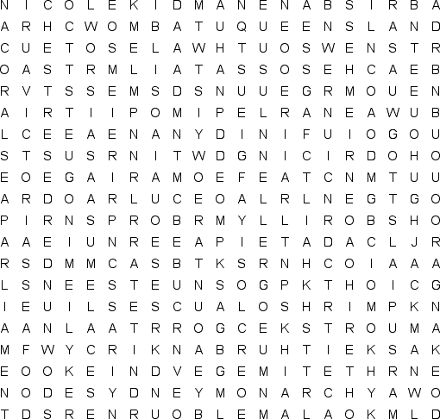
ADELAIDE  AUSSIE  BEACHES  BOOMERANG  BRISBANE  CANBERRA  COMMONWEALTH  CONTINENT  CORAL SEA  CROCODILES  DESERTS |  | DIDGERIDOO  DINGO  DOWN UNDER  EMUS  EUCALYPTUS TREES  HUGH JACKMAN  KANGAROO  KEITH URBAN  KOALA  KOOKABURRA  KYLIE MINOGUE |  | MARSUPIALS  MELBOURNE  MONARCHY  NEW SOUTH WALES  NICOLE KIDMAN  OCEANS  OUTBACK  PARLIAMENT  PERTH  PLATYPUS  PRIME MINISTER |  | QUEENSLAND  RAINFORESTS  RUSSELL CROWE  SEAFOOD  SHRIMP  SURFING  SYDNEY  TASMANIA  VEGEMITE  VICTORIA  WOMBAT

NGAMBAGA BINDARRY GIRRWAA COMMUNITY SERVICE INC.
CLIENT CODE OF CONDUCT
Client ‘Code of Conduct’ must be practiced when involved in NBGCS activities.
- All clients are required to:
- show your companions courtesy and respect;
- take any concerns you may have to the field worker;
- listen to the field workers instructions;
- not engage in disruptive or argumentative behaviour.

If a client cannot be respectful to others and continually disturbs other people then they may be asked to leave the outing and in extreme cases not be offered future services. Therefore, if a participant feels they cannot be respectful they should decide for themselves to not attend that activity on that day.
CLIENT ADVOCATES
An advocate is a person who, with the authority of the client, represents the client’s interests.
Clients may use an advocate of their choice to negotiate on their behalf. This may be a family member, friend or advocacy service.
Ngambaga Bindarry Girrwaa Community Service (NBGCS) will ensure that its clients are supported to make their own decisions and choices about how they will live their life.

NBGCS will assist its clients who require assistance to:
- speak on their own behalf;
- to identify available advocacy options (including guardianship);
- and to access (where available) an advocate and/or self-advocacy group.

Advocacy is a process of standing beside an individual and speaking out on their behalf to protect and promote their rights and interests.

Clients wishing to use an advocate should inform NBGCS in writing of the name of the person they wish to negotiate on their behalf. Clients have the right to change their advocate at any time and should inform NBGCS in writing of any change. Clients should complete the Authority to Act as an Advocate form.
Clients have the right:
- To quality of care in a safe and secure environment
- To privacy, dignity and respect
- To express their individuality and independence
- To get information, the right to choose, and the right to make a complaint
- To have access to an advocate of their choice

