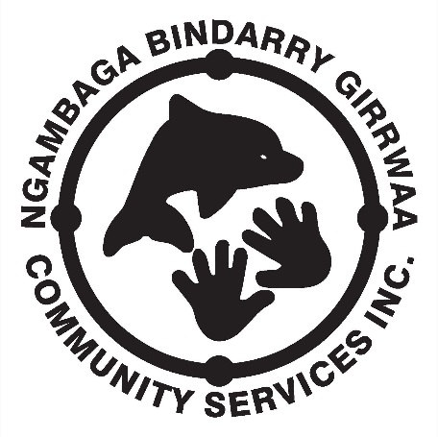

NEWSLETTER

March 2015 – Issue 9

I pay respect to the past, present and future Elders of the Nambucca Valley region on whose land I walk, work and live.

On the 6th February, NBGCS and Coffs Harbour, Bellingen, and Nambucca Community Transport conducting the annual Elder’s pre-Olympics at Bowraville Recreational Grounds. With the football grounds being extremely wet the event was changed over to the excellent facilities at the centre and all went well. Abcare from Coffs Harbour were the main ‘rivals’ to NBGCS; however Jagun Social group and MacLean Social group also participated resulting in everybody having a lot of fun. This year there were no set ‘teams’ with individuals competing on behalf of their Social group. Those who had difficulty participating in the more physically demanding games were able to pick and choose what they competed in and their points were combined with other members to give an overall group tally. To add a bit of a challenge to events the local primary school, St Marys, brought their kinder through to year 3 kids along to join in; the Elders were extremely helpful to the younger generation and appeared to enjoy their participation. Competition was strong with all competitors giving their best, although most people still had enough energy to engage in a bit of ‘sledging’ in an attempt to put the other team off their game. Overall the scores were very close however for the first time in 8 years Abcare was able to hold out NBGCS and take the trophy to Coffs Harbour. NBGCS now has a space on the top shelf that we will attempt to re-fill in 2016. Final scores for the event:

* Abcare Coffs Harbour – 45 points;
* NBGCS Nambucca Valley – 44 points;
* Jagun Coffs Harbour – 37 points;
* MacLean – 31 points.

Thank you to all the competitors for such a lively competition. It was great to see Jagun and MacLean travel down to compete and I hope they are able to do so in years to come.

I would like to say a big thank you to the NBGCS staff who worked tirelessly all day making sure the Elders did not want for anything and had a good time. Rachael Roberts, Lavinnia Inglis, and Kerri Bartlett ensured there was an endless supply of water and refreshments; William Kennedy, with the support of Medicare Local’s Terry Donovan, kept the Bar-B-Q going; Col and Marion from Community Transport who assisted with the scoring; and Rachael Gillin worked non-stop to ensure events flowed as smoothly as possible and joined all staff at the end of the day to get all the washing up and tidying completed. A big effort by all; the games could not have been such a success without the efforts you all contributed.



***A message from our C.E.O***

On Friday 27th February we will be conducting the first Member’s Forum for 2015; the forum will be held at the Bowraville office and will start at 10.00am. NBGCS would like to invite all Members to attend and put forward their ideas on the future of the Corporation. During the meeting representatives from the NSW Department of Aboriginal Affairs, Ken McIntosh and Penny Stadhams, and the Commonwealth Governments Department of Prime Minister and Cabinet, Kristy Swain, will give presentations regarding their relative departments. I am sure the presenters will allow plenty of time for Members to ask any questions they may have.

Ensuring NBGCS clients receive the best quality service available is not always easy and sometimes things can go a little wrong. NBGCS staff and management continually ask our clients what type of activities they would like to participate in and wherever possible we try to deliver what has been requested. Recently there have been some complaints about the location of an activity as it was considered by several clients to be more suitable to the younger generations then their age group. In response to the complaints I can only state that this was the last possible venue NBGCS could use to deliver this particular activity. The other couple of venues had been deemed unsuitable by our clients because of steep terrain and long distances to walk to get there. I will attempt to track down a venue that does not have these drawbacks however until then I will instruct my staff that NBGCS will not deliver activities that may present a problem, either physical or emotional, to clients. I ask that our clients understand that NBGCS will endeavour to give them the service they deserve however we cannot supply a service if there is no suitable venue available in the region.

There has also been some comment regarding the supply of refreshments whilst travelling. Wherever possible NBGCS will have an ample supply of refreshments for clients however there will be the odd occasions when due to unforeseen circumstances supplies may be low. My staff and I will make sure that in future we keep an extra supply of refreshments on hand for emergencies.

During recent conversations a few Client’s raised concerns regarding the Policy for selection of clients to attend NBGCS facilitated special social activities. This policy was requested and introduced by Clients and Members at the Community meeting conducted on the 22nd August 2014. I have included extracts from the Community meeting minutes; and the Board of Directors meeting minutes conducted to ratify the Member’s request. Basically what was requested by Member’s and Clients was that Clients had to attend a minimum of 12 social support activities/events before they were eligible to participate in NBGCS facilitated special social activities such as the Elders Olympics and the NBGCS Clients annual ‘away’ trip. NBGCS maintains a record of client attendance at activities and events so that there is no confusion around how many times a client has attended events. Clients should have no difficulty in attending 12 events each year as NBGCS provides activities for all clients at least twice a week plus there are Wellness Days every month. NBGCS delivers 17 regular activities every month; 4 women’s, 4 men’s; and 9 combined. For example if a male client was to attend the men’s day and combined day each week plus the Wellness Day each month he would attend the required 12 activities within five weeks. Considering that the recording of attendance commenced in September 2014 there would not be many clients who have not already attended 12 NBGCS facilitated activities or events. If you have any further concerns regarding this issue please do not hesitate to contact me or come into my office and have a chat next time you are in the area.

Enjoy life and have a great day.

Gary Butler

**Raffle!**

NBGCS have a large plasma television that we will be raffling. Costs are: $1/ticket or $2 for 3. All funds raised go towards new chairs for our art/craft room & the raffle will be drawn during NAIDOC week.

**REMINDER**

*Elders Olympics in Taree on 6th & 7th May -*

*The Elders Olympics fee commence payment $100 per head*

MARCH 2015 CALENDER

|  |  |  |  |  |
| --- | --- | --- | --- | --- |
| MON | TUE | WED | THU | FRI |
| 2. | 3.  **Respite Day** | 4.  **Women’s Day** | 5.  **Men’s Day** | 6. |
| 9. | 10.  **Carer Day** | 11.  **Women’s Day** | 12.  **Men’s Day** | 13. |
| 16. | 17.  **Respite Day** | 18.  **Women’s Day** | 19.  **Men’s Day** | 20. |
| 23. | 24.  **Carer Day** | 25.  **Women’s Day** | 26.  **Men’s Day** | 27. |
|  |  |  |  |  |
|  |  |  |  |  |
|  |  |  |  |  |
|  |  |  |  |  |
|  |  |  |  |  |
|  |  |  |  |  |
|  |  |  |  |  |
|  |  |  |  |  |
|  |  |  |  |  |



# ***MARCH BIRTHDAYS***

Roseina Boston – 3rd March

Valla Cohen – 10th March

Rosalind Donovan – 17th March

Wade Blair – 18th March

Elaine Callaway – 26th March

Happy Birthday

**NGAMBAGA BINDARRY GIRRWAA COMMUNITY SERVICE INC.**

**CLIENT CODE OF CONDUCT**

***Client ‘Code of Conduct’ must be practiced when involved in NBGCS activities.***

* All clients are required to:
* show your companions courtesy and respect;
* take any concerns you may have to the field worker;
* listen to the field workers instructions;
* not engage in disruptive or argumentative behaviour.

If a client cannot be respectful to others and continually disturbs other people then they may be asked to leave the outing and in extreme cases not be offered future services. Therefore, if a participant feels they cannot be respectful they should decide for themselves to not attend that activity on that day.

**HELPING YOU PUT A MEAL ON THE TABLE**

**C3 FOOD HUB**

**Each FRIDAY 9.30am – 12 noon**

Anyone holding a Health Care card or Pension card can access this service.

Lots of non-perishable food products + free bread, fruit & veg.

**Access fee:**

**$10 = 11 items**

**$20 = 22 items**

**Community Centre**

Corner of Ridge St & Creek St

**Nambucca Heads**



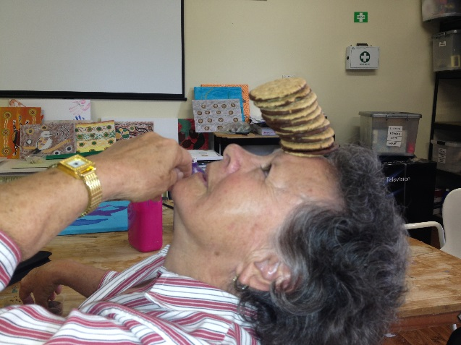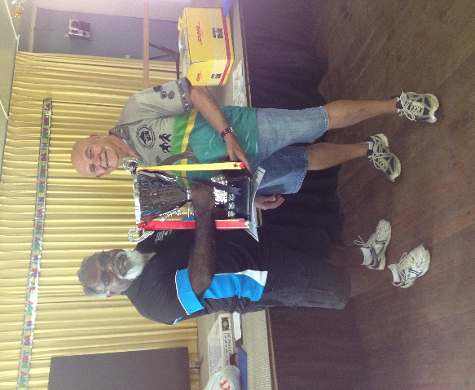

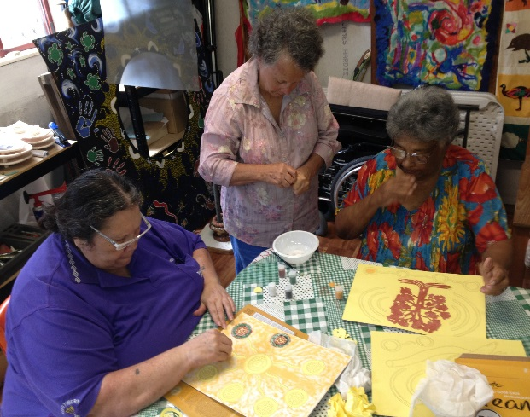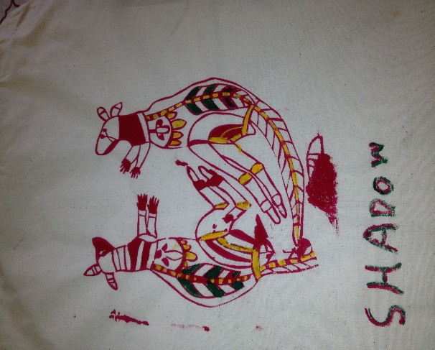

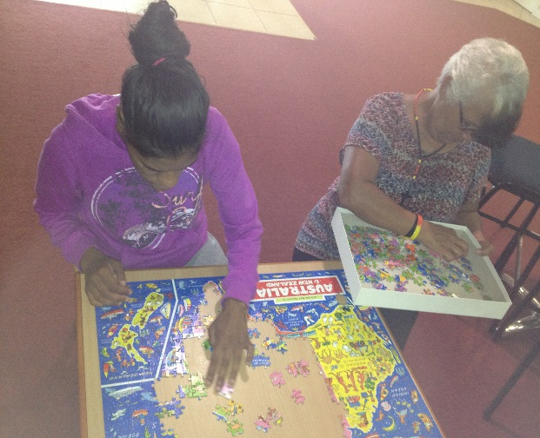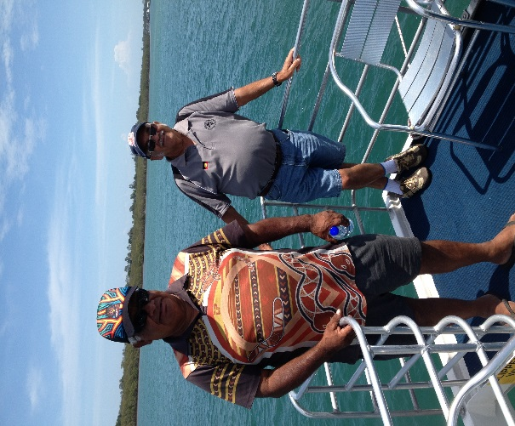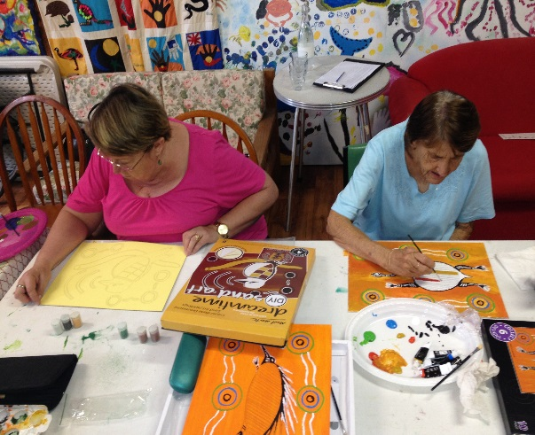

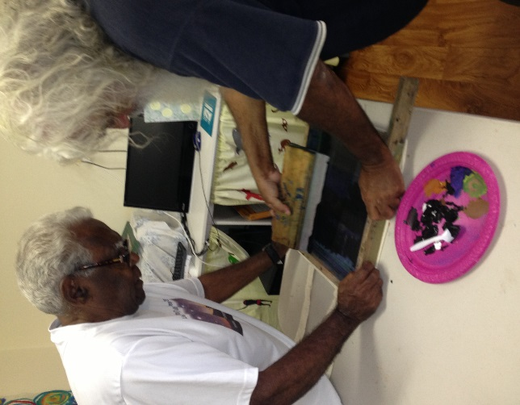

**CLIENT CARE PLANS**

Ngambaga Bindarry Girrwaa Community Service (NBGCS) takes a holistic approach to the development of client care plans.

All clients have the right to participate fully in the care planning process and have choice over the services they receive and how they receive them.

All clients will have an individually tailored care plan which reflect identified needs and special and / or cultural needs. The Care Plan will be developed in conjunction with their family, carer or advocate and the service Coordinator.

The care plan will identify the service/s to be provided, the frequency of service provision, reviews, any coordination with other service provider, together with all service conditions, information, rights and responsibilities and any special requirements. The care plan will be developed by the Coordinator in discussion with the client following assessment and agreement to provide a service.

In developing the care plan, NBGCS will ensure that:

* Clients are involved in decision making about the plan design, review and implementation;
* Clients can nominate an advocate or representative as part of the process
* Individual needs and preferences are taken into account. These may include:
* physical needs;
* emotional needs;
* cultural and religious needs;
* socio-economic needs.
* The client is aware of and able to choose from the range of relevant services or service providers available in the community;
* The client is aware of their rights and responsibilities
* As part of the individual care plan, each client is required to have a planned response for when they do not respond to a scheduled visit. Such a response needs to be documented in the client care plan or service agreement with a copy made available to the client.
* If services are required every day, arrangements for public holidays and weekends should be written into the care plan.
* The Care Plan will include a review date and other relevant documents: Activity Schedule, Consent Form, Emergency Plan, Signed Service Agreement (unless client chooses to not sign), and Risk Assessment Form
* Once the Care Plan has been developed and this is accepted by the client, the Coordinator and the client/client representative must sign and date the Client Agreement. A copy of the agreement is provided to the client and the original is filed in the client record