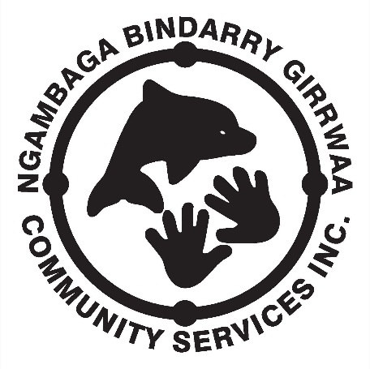
NEWSLETTER
April 2015 – Issue 9

I pay respect to the past, present and future Elders of the Nambucca Valley region on whose land I walk, work and live.
On the 17th March, NBGCS conducted the first Client meeting for 2015; attendance was very good with 24 Clients participating. A number of issues were clarified and most Clients left the meeting with a better understanding of what is happening in the Aged Care and respite industries. There was a considerable amount of debate around the Elder’s Olympics being held in Taree on 7th May 2015. The points that came out of the discussion where:
- Clients must attend 12 NBGCS events (outings; meetings; activity days; etc) to be eligible to attend the Olympics;
- Clients who only wish to be spectators are still able to attend;
- Clients who are known to have a physical disability that may hinder their ability to participate in the Olympics will be requested by NBGCS Management to produce a statement from their Doctor that clears them for competition, the certificate should state something like ‘Gary Butler is capable of performing medium to heavy physical activity for an extended period of time.’ NBGCS can refuse to allow the Client to participate if they do not have the requested clearance certificate.
- If any more than 30 Clients attending than additional transport will need to be arranged;
- Clients must register for the Elder’s Olympics by 17th April 2015;
- Client fees ($100) must be paid by 1st May 2015;
- Any Client who has registered and paid their fee but has not attended 12 NBGCS events by 1st May 2015 will have their fee refunded;
- Clients will travel to Taree on Wednesday 6th May, compete in the Olympics on Thursday 7th May, and return to the Nambucca Valley on Friday 8th May.;
- Accommodation will be at the All Seasons Motel Taree (the same as for Xmas lunch last year) and will be on a shared basis.
I would like thank all the NBGCS Clients who attended the meeting for their input and participation.
A Member’s Forum will be conducted this Friday 27th March at the Bowraville office, starting at 10.00am. I will report on the outcomes of this meeting in the May newsletter.
The annual Client’s Easter lunch will be held at Valla on Thursday 1st April; all are welcome so please come along and have a fun day.
Enjoy life and have a great day.

Gary Butler

A message from our C.E.O

Hello There All You Deadly Mob,
First of all I would like to thank you all for your patience during the month (March) as I settled into my new roll (Social Support Co-Ordinator).
As things are now settling down we will go back to the normal pick up arrangements:
- Out of the valley-pick up points.
- Local-pick up from home.

We have had a great month, from staff attending meetings about the changes to the men and women going to the winery and tasting the different wines.
As you are aware, water aerobics has commenced. NBGCS has gone into partnership with Galambila to run this program.

We are now planning for the next 3 months, so please, if you have any new ideas please let us know… We are ALWAYS open to new things.

There will be NO activities during the Easter period, from Monday 6th April 2015- Friday 17th April 2015.
Activities to commence on Monday 20th April 2015.

Hope you all have yas running shoes ready for the Olympics. It’s our year to bring it home!

Keep smiling & stay deadly!

Rachael Roberts
Social Support Co-Ordinator.

Hi everyone.
It’s so good to see so many people turning up for our outings, lots of fun laughing and yarning up.
We are having some great outings lately aren’t we? The women had the great day at Bago Winery, and what a beautiful day at Bellwood Park last Friday,
A big thank you to the girls for all their efforts making us comfortable and feeding us and Bill and Robbie for making sure the BBQ went well the meat was delicious
I am looking forward to more fun days and the Olympics will be here before we know it. Don’t forget to get your money in so nobody misses out on going.
Keep smiling and be happy!! Sue Suttle.

APRIL 2015 CALENDER
MON | TUE | WED | THU | FRI
 |  | 1. | 2.  Easter Luncheon  Valla Reserve | 3.  Good Friday  Public Holiday
6.  Easter Monday  Public Holiday | 7. | 8. | 9. | 10.
13. | 14. | 15. | 16. | 17.
20. | 21.  Carers Day  Butterfly House | 22.  Women’s Day  Lemon Myrtle  Taylors Arm | 23.  Men’s Day  9 Pin Kegel  Coffs Hbr | 24.
27.  Wellness Day | 28.  Respite Day  9 Pin Kegel  Coffs Hbr | 29.  Women’s Day  Art & Craft  Office | 30.  Men’s Day  Art & Craft  Office

No outings due to School Holdays

HAPPY BIRTHDAY!
Alex Blair – 3rd April
Robbie Edwards – 5th April
Marilyn Smith – 26th April

PUZZLE PAGE
(Answers on last page)
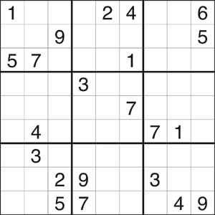

Across
1. A ___ in sheep's clothing (4)
3. Snakes and ___ (7)
9. One good turn deserves ___ (7)
10. Day and ___ (5)
11. Less ___ more speed (5)
12. Aided and ___ (7)
14. From rags to ___ (6)
16. No man is an ___ (6)
20. A ___ audience (7)
22. ___ and uncles (5)
24. ___ influence (5)
26. ___ and lightning (7)
27. Act in haste, repent at ___ (7)
28. A ___ end job (4)

Down
1. Under the ___ (7) 18. To achieve the ___ effect (7)
2. If ___ could kill (5) 19. A red ___ day (6)
4. At home and ___ (6) 20. Join the ___ (4)
5. Song and ___ man (5) 21. Any more bright ___? (5)
6. Like a red ___ to a bull (3) 23. A ___ and a wink (5)
7. Say ___! (6) 25. Do or ____ (3)
8. ___ poker (4)
13. ___ and sympathy (3)
15. ___ and saucer (3)
17. The ___ quo (6)

NGAMBAGA BINDARRY GIRRWAA COMMUNITY SERVICE INC.
CLIENT CODE OF CONDUCT
Client ‘Code of Conduct’ must be practiced when involved in NBGCS activities.
- All clients are required to:
- show your companions courtesy and respect;
- take any concerns you may have to the field worker;
- listen to the field workers instructions;
- not engage in disruptive or argumentative behaviour.

If a client cannot be respectful to others and continually disturbs other people then they may be asked to leave the outing and in extreme cases not be offered future services. Therefore, if a participant feels they cannot be respectful they should decide for themselves to not attend that activity on that day.

POLICY & PROCEDURE HANDBOOK - VOLUNTEERS
Ngambaga Bindarry Girrwaa Community Service (NBGCS) recognises the valuable contribution volunteers make to the service and actively encourage volunteer participation because it:
- enables volunteers to contribute to their community
- provides the opportunity for work experience and the development of new skills in volunteers
- enhances the range of services available through NBGCS
- allows for wider community participation in the service.
The recruitment process for volunteers will not discriminate on the grounds of gender, pregnancy, race, marital status, sexuality, age or disability.

All volunteers must sign a Volunteer Agreement before commencing work and complete an orientation process.
Community members can approach NBGCS if they are interested in volunteering with the organisation.
NBGCS will also call for volunteers via its newsletter and through other appropriate channels.
The CEO will arrange an interview with the prospective volunteer which will cover areas relating to them.
The volunteer will be informed as soon as possible as to his/her suitability for the roles required and, if the application is rejected, provided with an explanation.
All new volunteers will undergo a National Criminal History Record Check and a Working with Children Check (if relevant) before they first commence their duties with the HACC and Disability Services. Ongoing voluntary work with the organisation is subject to a satisfactory outcome from these checks.

Solutions to Puzzles
Sudoku 1. Sudoku 2.
